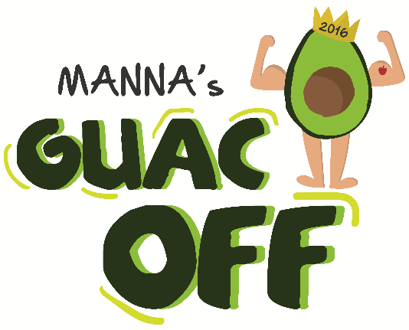

MEDIA ADVISORY

FOR IMMEDIATE RELEASE

CONTACT: Emily Gallagher
MANNA
(215) 496-2662 x 127
EGallagher@mannapa.org

TOP PHILLY RESTAURANTS COMPETE FOR THE BEST GUACAMOLE
AT THE 4th ANNUAL GUAC OFF TO BENEFIT MANNA

Philadelphia, PA — The 4th Annual Guac Off is at Morgan's Pier on the riverfront Thursday, May 26 from 6 - 9 pm. The best chefs and restaurants from Philadelphia compete for the title of Guac Master. More than 500 guests will sample 11 varieties of unlimited guacamole and chips, enjoy drink specials and help crown Guac Master 2016. Proceeds from the event benefit MANNA’s clients battling life-threatening illnesses.

Guac Off Competitors: Besito Mexican Restaurant Ardmore, Cafe Ynez, Cantina Dos Segundos, Los Camaradas, Lucha Cartel, Morgan's Pier, Revolution Taco, Square 1682 Restaurant, Whole Foods Market Philly and Xochitl.

Two winners are selected, one chosen by a panel of judges and the other by a people’s choice vote. Guac Off’s 2016 judge panel includes: Marilyn Russell of 95.7 Ben FM, Alex Holley of Fox 29’s Good Day Philadelphia, Ian Hussey of Pennsylvania Ballet, former Guac Master Robert Legget of Guerrilla Ultima and Eric Gantz of MANNA.

The event is sponsored by Performance Food Group.

Tickets are available on MANNA’s website: mannapa.org/guacoff.

###

About MANNA
Especially for people at acute nutritional risk due to life-threatening illnesses, MANNA prepares and delivers delicious nourishing meals and counsel, empowering individuals to battle illness and improve their quality of life. A small professional staff and 2,500 dedicated volunteers bring more than 80,000 nutritious, home-delivered meals each month to individuals and families living with HIV/AIDS, cancer and other life-threatening illnesses. MANNA dietitians promote wellness through nutrition education and counseling. Through these services, MANNA provides opportunities for caring people to extend loving support to families, friends, and neighbors. MANNA is spelled in all capital letters.

